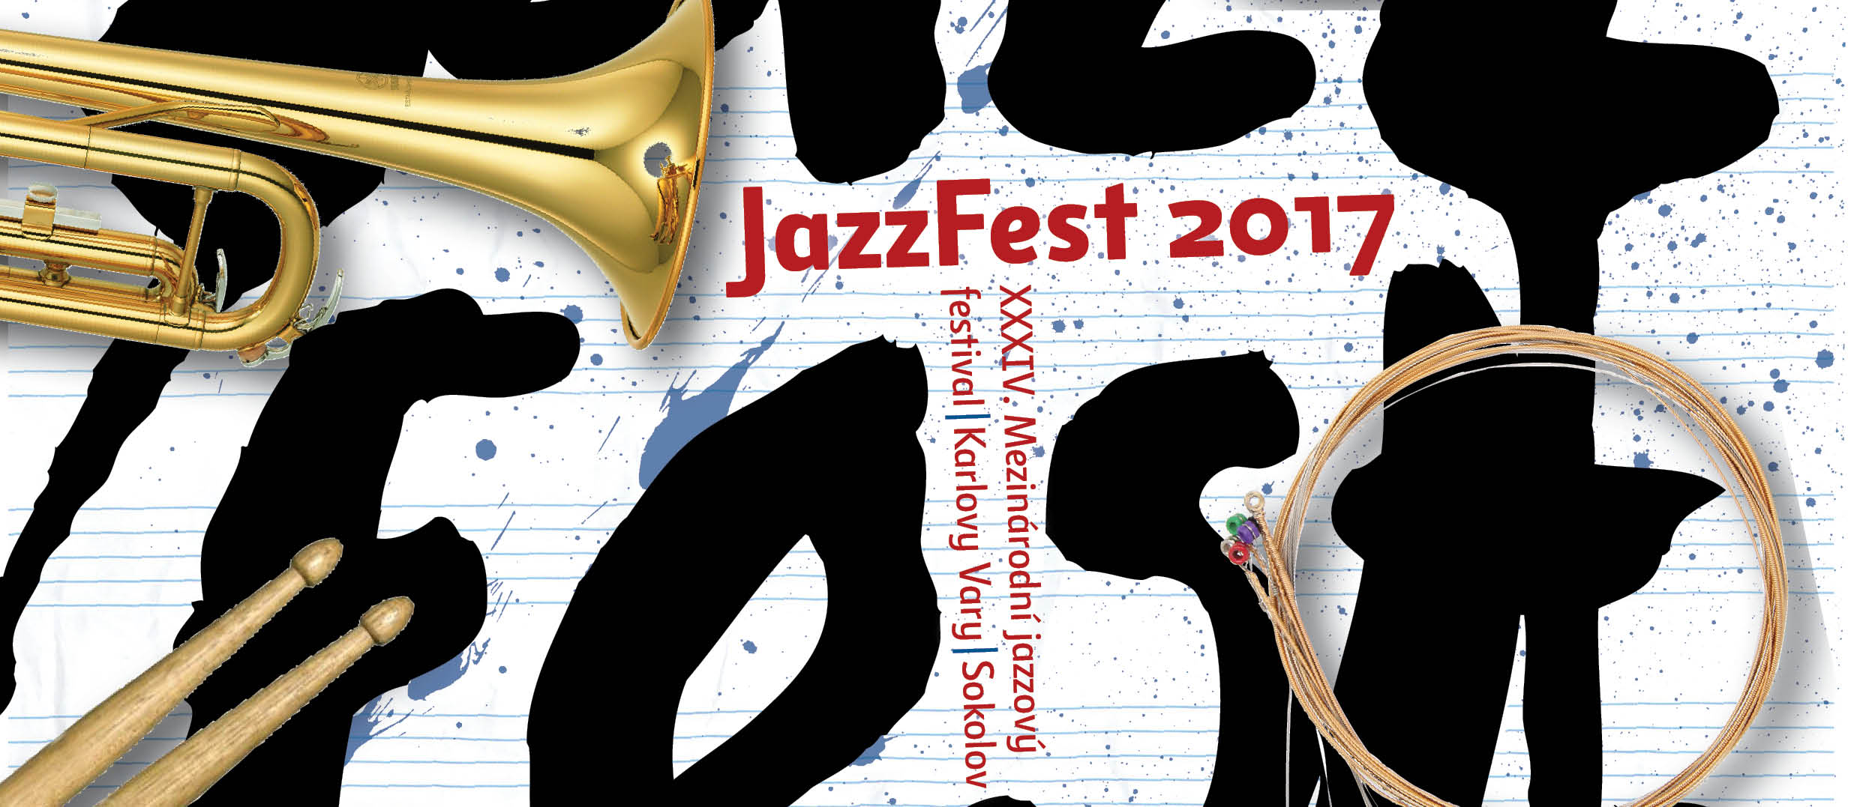
PRESS RELEASE

The 34th International jazz festival JAZZFEST KARLOVY VARY – SOKOLOV 2017 will offer six concerts in total, where the most important four of them will take place in the second half on October. For the last eighteen years, the Festival has been organized by the Jazzový kruh (Jazz circle) with his director and an active participant of the festival in one person – saxophonist Milan Krajíc. The festival has been traditionally supported by the Municipality of Karlovy Vary and the Karlovy Vary Region and held under the auspices of the Mayor of Karlovy Vary Ing. Petr Kulhánek.
The festival focuses on modern jazz, overlapping to different branches and to other music genres, including the symphonic music, by inviting outstanding musicians coming both from our country and abroad. The festival dramaturgy seeks to satisfy the demanding expert audience as well as the large non-jazz public.
On 24th September in Film Café a Kino Drahomíra Karlovy Vary, as a prelude to the festival, the trio Moussa Cissokho - Jan Galega Brönnimann - Omri Hason African Project will be introduced. In the trio, unlimited in genres, meets Moussa Cissokho, an exceptionally talented player on koru – a 24-string-harp and singer of Senegal origin, together with the Swiss bass clarinettist and saxophonist Jan Galega Brönnimann and the Israeli player on oriental percussions Omri Hason. The list of instruments is enough to guarantee an unusual musical experience.

Main festival concerts

In Sokolov on 4th October in the Municipal Theatre, one of the Czech jazz legends Martin Kratochvíl & Jazz Q will appear. Kratochvíl, a keyboard player and composer, is a famous musician known for connecting jazz and rock, who has a particular position in the history of the Czech jazz and rock.
The first festival concert will take place on 12th October in Grandhotel Ambassador Národní dům in Karlovy Vary. In the hall Orpheum Kryštof Marek Orchestra will play, together with the Karlovy Vary Symphony Orchestra. Kryštof Marek, pianist, composer and conductor already cooperated with the Symphony Orchestra several times and in this concert, Marek’s jazz vocal suite Midnight Pictures will be performed. After the awarding of the Baron Schoeneck Prize, which is a recognition and appreciation of important personalities associated with music in Karlovy Vary, Josef Vejvoda will be introduced. Josef Vejvoda is a legend of the Czech and Czechoslovak jazz, drummer and composer. In his suites, Celebration and Brazilian Pearl Jubilee a jazz quartet and the Karlovy Vary Symphony Orchestra will accompany him. Kryštof Marek will be the conductor of the entire concert.
The second main concert will be held on 18th October in the Art Gallery. The Czech quartet Limbo will appear on the stage, with its free music floating between various genres and putting a strong accent to improvisation, which only is possible due to many years of experience and extraordinary creativity of all musicians: bass clarinetist Pavel Hrubý, trumpeter František Kučera, contrabass player Taras Vološčuk and drummer Dušan Černák.
The formation Ondřej Štveráček Quartet feat. Gene Jackson will perform after Limbo. The tenor saxophonist with a Coltrane inspiration Ondřej Štveráček is one of the most significant personalities of the jazz generation that appeared on the stages at the beginning of the millennium. He started a cooperation with the renowned American drummer Gene Jackson who worked with many masters; he by himself considers the performances with Herbie Hancock and Dave Holland to be tops of his career. The Slovak pianist Klaudius Kováč and the Czech contrabass player Tomáš Baroš will join Ondřej Štveráček and Gene Jackson for this concert.
The third main festival concert will be given on 20th October in the Municipal Theatre in Karlovy Vary. First Jazz Big Gang will play; a twelve-membered ensemble which is led by the pianist Radim Vojíř and which is formed by young enthusiastic players, who have performed in various jazz and non-jazz groups. After them, the stage will welcome a large orchestra again – the East West European Jazz Orchestra feat. Deborah Carter & Norbert Gottschalk. This orchestra connects the west jazz with the east jazz to an international band of the highest quality. The project integrates different cultures; it seeks both beginners and jazz professionals from various European regions, with their unusual styles that are influenced by local regional tradition. With the orchestra conducted by Uwe Plath will appear the American singer Deborah Carter and the German singer Norbert Gottschalk. Deborah Carter is one of the best swinging jazz singers in the world, who worked with a huge number of renowned orchestras. Norbert Gottschalk belongs to reputable European singers, he is a Master of improvised jazz singing – scat, he is one of the top ten in the world.
The fourth and the final main festival concert will take place on 28th October in the Hotel Imperial. It will be opened by the home formation M. K. Collective with the saxophonist Milan Krajíc and the excellent singer Petra Brabencová. Their repertory is based on original songs unlimited in genres and on interesting arrangements of modern jazz standards by contemporary jazz world icons. The festival will be concluded by Marianne Solivan & Walter Fischbacher Trio.
The American singer Marianne Solivan has become one of the most quickly rising jazz singer stars in New York and she worked with many distinguished jazzmen. Marianne will be accompanied by a renowned personality of the modern jazz scene, the keyboard player of Austrian origin, Walter Fischbacher, who already performed in Karlovy Vary with his own band. Fischbacher is often compared to such legends as Joe Zawinul, Chick Corea and Herbie Hancock. He appears together with the Czech contrabass player Petr Dvorský and the German drummer Ulf Stricker.

