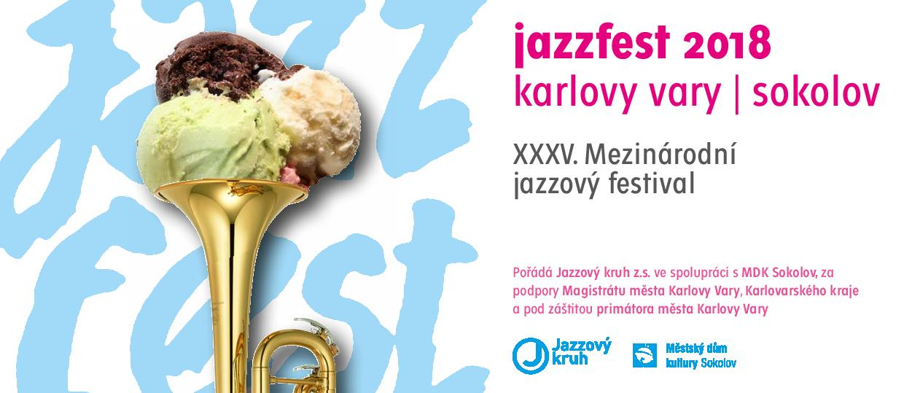

PRESS RELEASE

One of the most prominent representatives of the modern jazz and a double holder of the most prestigious Grammy award. That is the American jazz-fusion quartet Yellowjackets. Together with an exceptional singer Luciana Souza, the Grammy holder, too, they will be the top stars of 35th international jazz festival JAZZFEST KARLOVY VARY – SOKOLOV 2018. From September 22 to October 27 there will be six concerts held, both in big halls and clubs.
For the last nineteen years, the Festival has been organized by the Jazzový kruh company (Jazz circle) with its director and an active participant of the festival in one person – the saxophonist Milan Krajíc. The festival has been traditionally supported by the Municipality of Karlovy Vary and the Karlovy Vary Region and held under the auspices of the Mayor of Karlovy Vary Municipality Ing. Petr Kulhánek.
The festival focuses on modern jazz, overlapping to different branches and to other music genres, including the symphonic music, inviting outstanding musicians coming both from our country and abroad. The festival dramaturgy seeks to satisfy the demanding expert audience as well as the large non-jazz public.

Festival intro

The festival starts on September 22 in Slash Bar in Karlovy Vary with the concert of Mirka Novak, a Czech soul singer with unbeatable energy, who performs in USA. She will appear with the Ivan Audes Trio, led by an excellent drummer Ivan Audes, together with a young talented bass guitar player Emilie Bauerová and with an outstanding pianist Erich Ciompa.
Mirka Novak & Ivan Audes Trio will be followed by the Steve Clark Trio, led by an exquisite American bass guitar player Steve Clarke, who has been to Karlovy Vary several times – among others also with the trumpeter Laco Deczi. The same is true about an American pianist of Austrian origin, Walter Fischbacher, who appeared in the JazzFest with different bands. The trio will be accomplished by a young German drummer Richard Muenchhoff.
The concert will be concluded by Jazz Fancies formation. Beside the saxophonist and bandleader Milan Krajíc, the singer Petra Brabencová and the drummer Milan Krajíc jr., most musicians of this octet have come from the Karlovy Vary jazz milieu. The repertory includes their own compositions and pieces of different genres arranged by Milan Krajíc.

The October program starts in the Municipal house of culture in Sokolov on October 4, with the concert of the Pavel J. Ryba Trio & Mr. Fish. The musical art of Pavel J. Ryba is highly valued both in Europe and USA. He often cooperates with Czech pop and jazz musicians as well as with such world-known personalities like for example Mike Stern, Dean Brown and Gary Lucas, American guitar players, or a Polish keyboard virtuoso Josef Skrzek. His own pieces blend specific playing and melodic bass guitar feeling together with soulful expression of other musicians. The bass guitar player will appear with the bass clarinet player and saxophonist Petr Valášek and the percussion player Jiří Kollman.
Subsequently, Folhinha Band will perform, a band established ten years ago, formed by an Ecuador singer and pianist „Aru“ Andrea Ruilova-Barzola and Czech musicians. Their author pieces and texts in Latin-American style are inspired by Ecuador, Cuba, Brazil and Mexico, where Aru lived, studied, played and sang. She will be accompanied by the saxophonist Jakub Doležal, the guitar player Jiří Šimek, the bass guitar player Filip Spálený and the drummer Filip Jeníček.

Main and club concerts

The first main festival concert on October 10 will bring the event to the Grandhotel Ambassador Národní dům in Karlovy Vary. The concert is held in cooperation with the Karlovy Vary Symphony Orchestra to celebrate 120th anniversary of birth of the American composer George Gershwin. During the performance of the pianist Karel Košárek, the singer Petra Brabencová and the Karlovy Vary Symphony Orchestra, the audience will hear the most known pieces by George Gershwin: American In Paris and Rhapsody In Blue, followed by unforgettable songs by the Czech composer Jaroslav Ježek, whose work was strongly influenced by jazz. The orchestra will be conducted by Jan Kučera, its chief conductor.
The club concert on October 18 in cooperation with Club Paderewski will be started in Club Paderewski by baptizing a new CD issued by Vocal Band Quartet, which will be instrumentally supported by Henry Volf Trio, led by an excellent pianist Jindřich Henry Volf, and a jazz octet Karlovarský Repre Band, led by the saxophonist Milan Krajíc.
The second part of the evening will belong to the Elisabeth Lohninger Quartet. The main protagonist, an American singer of Austrian origin, Elisabeth Lohninger is a winner of many awards, introduced as emotive, exciting, dazzling and inspiring person. She will perform together with the pianist and keyboard player Walter Fischbacher, a Czech contrabass player Petr Dvorský and a German drummer Ulf Stricker. Fischbacher has been working with Elisabeth for 18 years, he is often compared to such legends as Joe Zawinul, Chick Corea and Herbie Hancock and he performed with Dvorský and Stricker during the last JazzFest.
The second main festival concert, held in cooperation with the Karlovy Vary Municipal Theatre, takes place on October 19 in the Karlovy Vary Municipal Theatre and represents the peak of the festival. The American band Yellowjackets with a Brazilian singer Luciana Souza will appear on the stage, introduced by a Czech vocal sextet Skety. The sextet gets the inspiration in jazz
a cappella ensembles, however it seeks to create its particular sound and style by crossing the limits, in borrowed and own pieces.
The Yellowjackets was established in 1981. The band without genre limits blends R&B, electric and acoustic music, blues and pop to its own style, which brought the band to two Grammy Awards and five Grammy nominations. The stage will welcome the founder member, bandleader and keyboard player Russell Ferrante, as well as the saxophonist Bob Mintzer, the band member since 1990. He belongs to hard bop devoted tenor saxophonists, who rose up from the New York School in the '70s, represented by Michael Brecker, Bob Berg, David Liebman and Steve Grossman. Mintzer is an exceptional arranger as well. He appeared as a soloist in the JazzFest three years ago. The drummer with polyrhythmic feeling, Will Kennedy, came to the band in 1987, but he was working on another projects between 1999 – 2010. The junior musician of the band (since 2015) is

a young Australian bass guitar player Dane Alderson.
The Brazilian singer and composer Luciana Souza sticks to classical and chamber music as well. She performed with many prominent orchestras. In the jazz field she worked with such musicians as Herbie Hancock, John Patitucci, Bobby McFerrin and many others. In 2007 she was Grammy awarded for her vocal performance on Herbie Hancock’s CD, she was nominated for many different jazz prizes for her own albums as well. The Association of the Jazz Journalists gave her a title of the Singer of the Year in 2005 and 2013.
The final concert of the festival held in cooperation with the Hotel Imperial on October 27 in Club Imperial will introduce an Australian-Czech formation Michelle Nicolle Quartet. The highly appreciated and valued singer Michelle Nicolle is considered to be the best contemporary jazz singer in Australia. She has been influenced by the music of Billie Holiday, Ella Fitzgerald and Chet Baker. Michelle Nicolle will be accompanied by a Czech guitar player Libor Šmoldas, one of the best of his generation, by an outstanding Hammond organ player Jakub Zomer and an Australian drummer Ronny Ferella, well-known in his country as well as internationally.

www.jazzfest.cz

