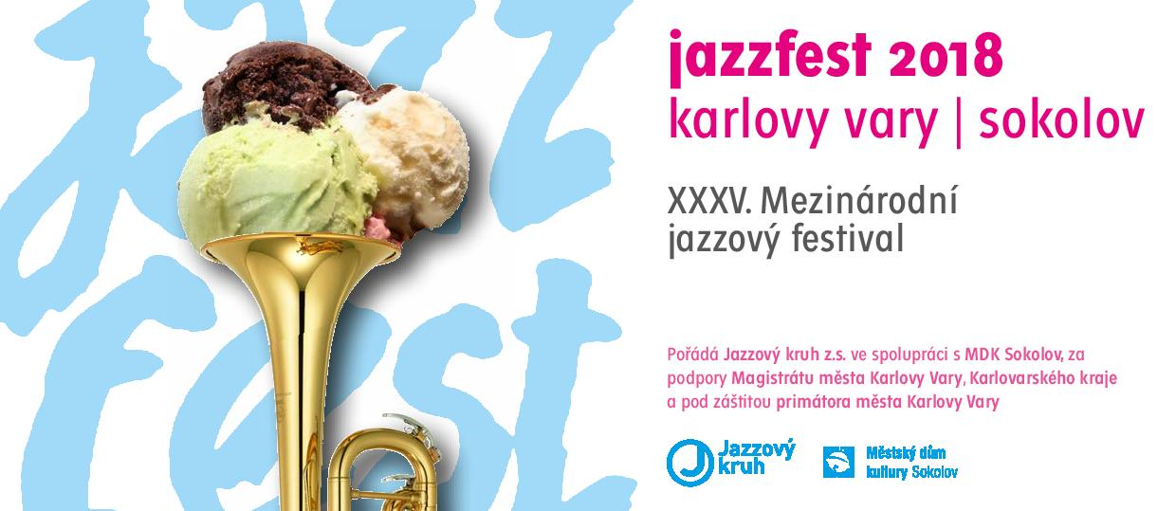
PROGRAM

22. 9. 2018, 20:00, Slash Bar, Karlovy Vary
club concert
Mirka Novak & Ivan Audes Trio (USA, CZE)
Steve Clarke Trio (USA, DEU)
Jazz Fancies (CZE)

4. 10. 2018, 19:00, Městský dům kultury (Municipal house of culture), Sokolov
in cooperation with the Municipal house of culture Sokolov
Pavel J. Ryba Trio & Mr. Fish (CZE)
Folhinha Band (ECU, CZE)

10. 10. 2018, 19:30, Grandhotel Ambassador Národní dům, Karlovy Vary
in cooperation with the Karlovy Vary Symphony Orchestra
Concert for 120th anniversary of birth of George Gershwin – the main festival concert
George Gershwin: American In Paris
George Gershwin: Rhapsody In Blue
Jaroslav Ježek: songs
Karel Košárek – pi, Petra Brabencová – voc, Karlovy Vary Symphony Orchestra, Jan Kučera – conductor

18. 10. 2018, 19:30, Club Paderewski in Husovka Theatre, Karlovy Vary
in cooperation with the Club Paderewski – club concert
Vocal Band Quartet & Henry Volf Trio & Karlovarský Repre Band (CZE)
Elisabeth Lohninger Quartet (USA, DEU, CZE)

19. 10. 2018, 19:30, Karlovarské městské divadlo (Municipal Theatre), Karlovy Vary
in cooperation with the Municipal Theatre Karlovy Vary – the main festival concert
Skety (CZE)
Yellowjackets feat. Luciana Souza (USA, BRA)

27. 10. 2018, 20:00, Club Imperial, Karlovy Vary
in cooperation with the Hotel Imperial – the closing concert
Michelle Nicolle Quartet (AUS, CZE)
www.jazzfest.cz

